Experiment -02
Title : Git Installation and Configuration, Repository Creation, Branching and Merging, Managing ML Project Source Code, Collaboration Using GitHub or GitLab, Maintaining Version History, Resolving Merge Conflicts, Documentation of Version Control Workflow.

1. Download Git
- Open a web browser.
- Go to the official Git for Windows download page.
- Download the Windows installer.
- Run the downloaded .exe file.
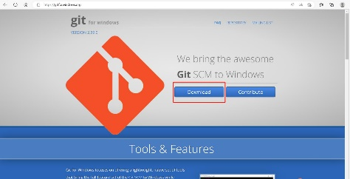
Step 1
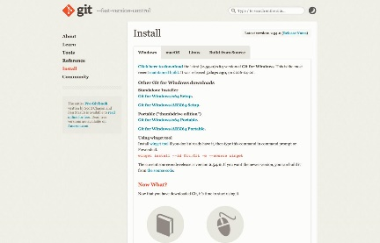
Step 2
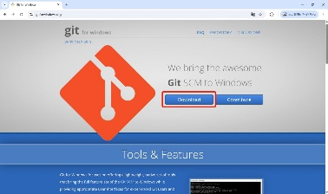
Step 3

2. Start Git Installation
- Double-click the downloaded Git installer.
- The Git Setup window will appear.
- Click Next to continue.

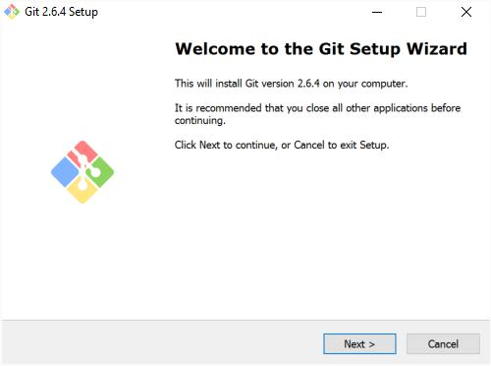
Step 4
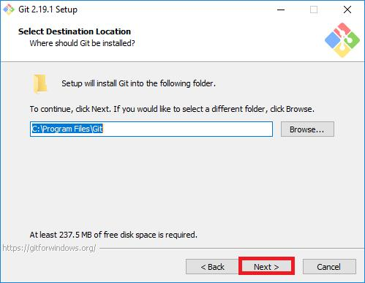
Step 5
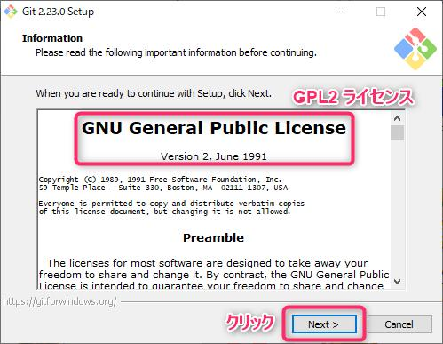
Step 6
3. Select Installation Location
- Keep the default installation location.
- Normally Git is installed in:
C:\Program Files\Git
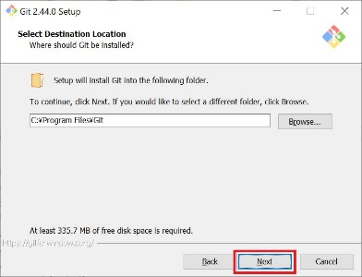
Step 7
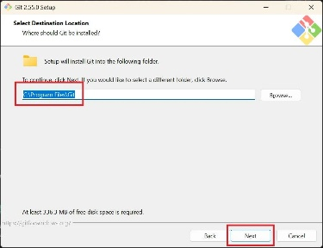
Step 8
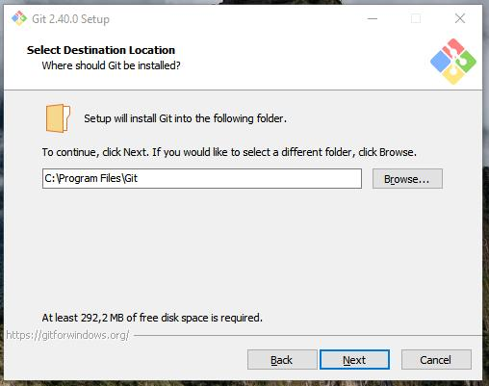
Step 9
4. Select Components
- Keep the default components selected.
- Ensure Git Bash Here and related options are available.
- Click Next.

5. Select Start Menu Folder
- Keep the default Start Menu folder.
- Click Next.
6. Choose Git Editor
- Select the preferred text editor.
- For beginners, the default editor can be used.
- Click Next.

7. Choose PATH Environment
1.Git from the command line and also from 3rd-party software
2.Then click Next
3.This allows Git commands to work from Command Prompt, PowerShell and Git Bash.

8. Complete Installation
- Keep the recommended default options.
- Click Install.
- Wait for the installation to complete.
- Click Finish.
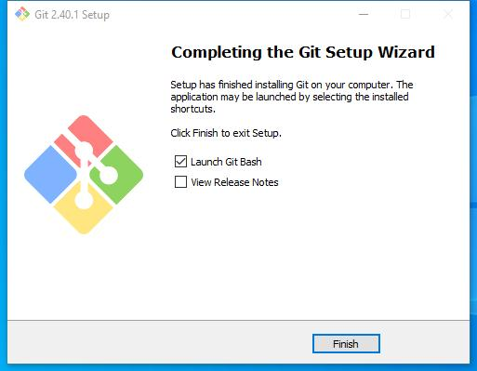
Step 10

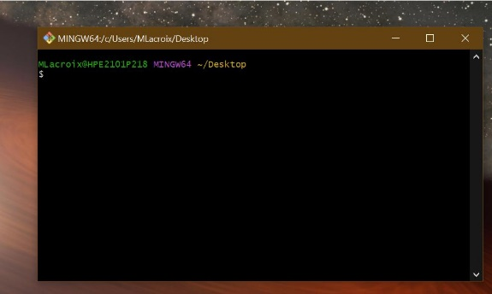

Fig: Gitbash

1. Git : Version control system

2. Command to generate key :
Command : ssh-keygen

After running the above command you will get the public key and you have to paste in the key column

3. git clone <git-url> : this command use to clone the remote repository to local

4. git add . : This command will move the all files and folders from local workspace to the Staging Area

5. git add <file-name> : to save the changes from Staging to Local Repo of the given filename

6. git log : Shows the detail log of the action we performed

7. git push origin main : this command will push the changes into the remote repository.
where,
main : the name of branch you want to push the data
origin : is the name of remote repository

8. git status : to see the untracked files for local workspace or to see the files properties for all workspace.

9. git pull origin main : pull the changes from the remote repository

10. git checkout -b <new-branch-name> -> this command will create the new branch with name develop
Ex : git checkout -b testing

11. git branch : it is used to display the current working branch.

12. git switch <branch-name> : to switch to another branch
Ex : git switch main

13. git push origin <branch-name> : this command will push the data to the given branch name.
Ex : git push origin testing

14. git merge <source-branch> <master-branch> : this command will merge the source branch data to master branch
Ex : git merge develop main (Here we are merging develop branch data to master branch data)

15. git log --oneline : to check all the commit log

16. Pulling a repo from remote repository :
Syntax : git branch -f <remote_branch_name> origin/<remote_branch_name>
Command : git branch -f company origin/company

where, company is the branch name in remote repository
Result
Git was successfully installed and configured on the system. The Git version, username, and email configuration were verified successfully.

